

Compsoft Technologies

Bangalore,Karnataka

AN INTERNSHIP REPORT ON

“ Leaf Now ”

## BACHELOR OF ENGINEERING

In

#### COMPUTER SCIENCE AND ENGINEERING

##### Submitted by: Pruthvi R(1MV19CS087)

##### Pruthvika S(1MV19CS088)

##### Under the Supervision of: Sumukh S Jadhav



Sir M Visweswaraya College of Engineering

(Affiliated to Visvesvaraya Technological University and Approved by AICTE, New Delhi)Accredited By NAAC with ‘A’ Grade

ISO 9001-2015 and 14001-2015 certified Institute

**BengAluru, KArnAtAkA 560057**

##### 2020-2021

**ABOUT THE COMPANY**

CST is a digital service provider that aims to provide software, designing and marketing solutions to individuals and businesses. At CST , we believe that service and quality is the key to success

We provide all kinds of technological and designing solutions from Billing Software to Web Designs or any custom demand that you may have. Experience the service like none other!

Some of our services include:

* Development - We develop responsive, functional and super-fast websites.
* We keep User Experience in mind while creating websites. A website should load quickly and shouldbe accessible even on a small view-port and slow internet connection.
* Mobile Application - We offer a wide range of professional Android, iOS& Hybrid app development services for our global clients, from a start up to a large enterprise.
* Design - We offer professional Graphic design, Brochure design & Logo design. We are expertsin crafting visual content to convey the right message to the customers.
* Consultancy - We are here to provide you with expert advice on your design and development requirement.
* Videos - We create a polished professional video that impresses your audience.

# Table of Contents

#### Contents Page No.

**Table of Contents I**

Overview of the project 1

About 2

Tools used 3

Implementation 4-25

Snapshots 26-27

Bibliography 28

##### (I)

### OVERVIEW OF THE PROJECT

**Project Name**: Leaf Now

**Team Members: Pruthvi R, Pruthvika S**

OVERVIEW

Ever since industrialization started the care for plants has made it to our least priority

list, even though mankind requires plants to balance the food chain that he’s a part of,

but the plant enthusiasts are everywhere, be it big metropolitan cities or rural areas,

so, we aim to bring in a platform that can connect these plant/nature enthusiasts and

help them exchange/sell them plants or donate seeds/plants as part of the green

initiative that we started 2 years back.

Key details on LEAF NOW:

The most crucial feature of LEAF NOW is connecting enthusiasts, which means that

users should be able to create an account on the site and can start filling out a form

to submit their services, which will later be published by our team if it is genuine

The second feature is encouraging users to sell/buy/donate plants/seeds, by

letting them know the importance of the same

The third important feature is the discussion page, which sets up a discussion

page for the enthusiasts to start a discussion on topics that they like (optional)

A pdf for every donation, a donation can be money (1rs for every plant) requires you

to convert web content to pdf encouraging other users to do the same.

**Project Name: Leaf Now**

This project is about plant donation. the main goal of the project is to help others to buys plant saplings, seeds, flowers online conveniently.

This project also aims at telling the importance of and sowing.

We have used css, html, javascrpit, php for completing our project

An HTML document defines the**structure of HTML web page**. It contains two distinct parts, the head, and the body. The head contains information about the document.

Cascading Style Sheets (CSS) is a style sheet language used for describing the presentation of a document written in a markup language such as HTML. CSS is a cornerstone technology of the World Wide Web, alongside HTML and JavaScript.

JavaScript Document object is an**object that provides access to all HTML elements of a document.** When an HTML document is loaded into a browser window, then it becomes a document object. The document object stores the elements of an HTML document, such as HTML, HEAD, BODY, and other HTML tags as objects.

PHP is an open-source, interpreted, and object-oriented scripting language that can be executed at the server-side. PHP is well suited for web development. Therefore, it is used to develop web applications (an application that executes on the server and generates the dynamic page.).

In this project user can register by providing his/her name, phone number, email id, password, location.

after registering user can login. And buy plant saplings/seeds/flowers and can add to cart.

After buying user can provide his review which will be useful for other buyers.

The user can also write blog about plant donation and sowing, to which other users can comment and start discussion.

This will provide a platform for discussion among buyers/other users.

### TOOLS USED

**Software Requirements**

* + Visual Studio Code 2019.
  + Google Chrome or Microsoft Edge of latest version.
  + Front End: HTML, CSS, JS
  + Backend: Php, MySQL, xampp
  + Linux 7.1 or Windows XP/7/8/10 OS or Mac OS

**Hardware Requirements**

* + Pentium 200-MHz computer with a minimum of 64 MB of RAM (128 MB of RAM recommended).
  + Monitor with a refresh rate of at least 40Hz for a smooth GUI experience (optional).

# IMPLEMENTATION

Index Page

<?php session_start (); ?>

<!DOCTYPE html>

<html lang="en">

    <head>

        <meta charset="UTF-8">

        <title>Leaf Now</title>

        <meta http-equiv="content-type" content="text/html; charset=utf-8" />

        <meta name="description" content="" />

        <meta name="keywords" content="" />

        <link href="bootstrap\css\bootstrap.min.css" rel="stylesheet">

        <script src="https://ajax.googleapis.com/ajax/libs/jquery/1.12.4/jquery.min.js"></script>

        <script src="bootstrap\js\bootstrap.min.js"></script>

        <!--[if lte IE 8]><script src="css/ie/html5shiv.js"></script><![endif]-->

        <link rel="stylesheet" href="login.css"/>

        <script src="js/jquery.min.js"></script>

        <script src="js/skel.min.js"></script>

        <script src="js/skel-layers.min.js"></script>

        <script src="js/init.js"></script>

        <noscript>

            <link rel="stylesheet" href="css/skel.css" />

            <link rel="stylesheet" href="css/style.css" />

            <link rel="stylesheet" href="css/style-xlarge.css" />

        </noscript>

        <link rel="stylesheet" href="indexfooter.css" />

        <!--[if lte IE 8]><link rel="stylesheet" href="css/ie/v8.css" /><![endif]-->

    </head>

    <?php

        require 'menu.php';

    ?>

        <!-- Banner -->

            <section id="banner" class="wrapper">

                <div class="container">

                <h2>Leaf Now</h2>

                <p>Your Product Our Market</p>

                <br><br>

                <center>

                    <div class="row uniform">

                        <div class="6u 12u$(xsmall)">

                            <button class="button fit" onclick="document.getElementById('id01').style.display='block'" style="width:auto">LOGIN</button>

                        </div>

                        <div class="6u 12u$(xsmall)">

                            <button class="button fit" onclick="document.getElementById('id02').style.display='block'" style="width:auto">REGISTER</button>

                        </div>

                    </div>

                </center>

            </section>

        <!-- One -->

            <section id="one" class="wrapper style1 align-center">

                <div class="container">

                    <header>

                        <h2>Leaf Now</h2>

                        <p>Explore the new way of trading...</p>

                    </header>

                    <div class="row 200%">

                        <section class="4u 12u$(small)">

                            <i class="icon big rounded fa-clock-o"></i>

                            <p>Digital Market</p>

                        </section>

                        <section class="4u 12u$(small)">

                            <i class="icon big rounded fa-comments"></i>

                            <p>Leaf-Blog</p>

                        </section>

                        <section class="4u$ 12u$(small)">

                            <i class="icon big rounded fa-user"></i>

                            <p>Register with us</p>

                        </section>

                    </div>

                </div>

            </section>

        <!-- Footer -->

        <footer class="footer-distributed" style="background-color:black" id="aboutUs">

        <center>

            <h1 style="font: 35px calibri;">About Us</h1>

        </center>

        <div class="footer-left">

            <h3 style="font-family: 'Times New Roman', cursive;">Leaf Now &copy; </h3>

        <!--    <div class="logo">

                <a href="index.php"><img src="images/logo.png" width="200px"></a>

            </div>-->

            <br />

            <p style="font-size:20px;color:white">Your product Our market !!!</p>

            <br />

        </div>

        <div class="footer-center">

            <div>

                <i class="fa fa-map-marker"></i>

                <p style="font-size:20px">Leaf Now<span>Vormir</span></p>

            </div>

            <div>

                <i class="fa fa-phone"></i>

                <p style="font-size:20px">123456789</p>

            </div>

            <div>

                <i class="fa fa-envelope"></i>

                <p style="font-size:20px"><a href="mailto:agroculture@gmail.com" style="color:white">demo@demo.com</a></p>

            </div>

        </div>

        <div class="footer-right">

            <p class="footer-company-about" style="color:white">

                <span style="font-size:20px"><b>About leaf now</b></span>

                Leaf Now is e-commerce trading platform for plants & seeds...

            </p>

            <div class="footer-icons">

                <a  href="#"><i style="margin-left: 0;margin-top:5px;"class="fa fa-facebook"></i></a>

                <a href="#"><i style="margin-left: 0;margin-top:5px" class="fa fa-instagram"></i></a>

                <a href="#"><i style="margin-left: 0;margin-top:5px" class="fa fa-youtube"></i></a>

            </div>

        </div>

    </footer>

            <div id="id01" class="modal">

  <form class="modal-content animate" action="Login/login.php" method='POST'>

    <div class="imgcontainer">

      <span onclick="document.getElementById('id01').style.display='none'" class="close" title="Close Modal">&times;</span>

    </div>

    <div class="container">

    <h3>Login</h3>

                            <form method="post" action="Login/login.php">

                                <div class="row uniform 50%">

                                    <div class="7u$">

                                        <input type="text" name="uname" id="uname" value="" placeholder="UserName" style="width:80%" required/>

                                    </div>

                                    <div class="7u$">

                                        <input type="password" name="pass" id="pass" value="" placeholder="Password" style="width:80%" required/>

                                    </div>

                                </div>

                                    <div class="row uniform">

                                        <p>

                                            <b>Category : </b>

                                        </p>

                                        <div class="3u 12u$(small)">

                                            <input type="radio" id="farmer" name="category" value="1" checked>

                                            <label for="farmer">Farmer</label>

                                        </div>

                                        <div class="3u 12u$(small)">

                                            <input type="radio" id="buyer" name="category" value="0">

                                            <label for="buyer">Buyer</label>

                                        </div>

                                    </div>

                                    <center>

                                    <div class="row uniform">

                                        <div class="7u 12u$(small)">

                                            <input type="submit" value="Login" />

                                        </div>

                                    </div>

                                    </center>

                                </div>

                            </form>

                        </section>

</div>

    </div>

    </div>

  </form>

</div>

<div id="id02" class="modal">

  <form class="modal-content animate" action="Login/signUp.php" method='POST'>

    <div class="imgcontainer">

      <span onclick="document.getElementById('id02').style.display='none'" class="close" title="Close Modal">&times;</span>

    </div>

    <div class="container">

<section>

                            <h3>SignUp</h3>

                            <form method="post" action="Login/signUp.php">

                                <center>

                                <div class="row uniform">

                                    <div class="3u 12u$(xsmall)">

                                        <input type="text" name="name" id="name" value="" placeholder="Name" required/>

                                    </div>

                                    <div class="3u 12u$(xsmall)">

                                        <input type="text" name="uname" id="uname" value="" placeholder="UserName" required/>

                                    </div>

                                </div>

                                <div class="row uniform">

                                    <div class="3u 12u$(xsmall)">

                                        <input type="text" name="mobile" id="mobile" value="" placeholder="Mobile Number" required/>

                                    </div>

                                    <div class="3u 12u$(xsmall)">

                                        <input type="email" name="email" id="email" value="" placeholder="Email" required/>

                                    </div>

                                </div>

                                <div class="row uniform">

                                    <div class="3u 12u$(xsmall)">

                                        <input type="password" name="password" id="password" value="" placeholder="Password" required/>

                                    </div>

                                    <div class="3u 12u$(xsmall)">

                                        <input type="password" name="pass" id="pass" value="" placeholder="Retype Password" required/>

                                    </div>

                                </div>

                                <div class="row uniform">

                                    <div class="6u 12u$(xsmall)">

                                        <input type="text" name="addr" id="addr" value="" placeholder="Address" style="width:80%" required/>

                                    </div>

                                </div>

                                <div class="row uniform">

                                    <p>

                                        <b>Category : </b>

                                    </p>

                                    <div class="3u 12u$(small)">

                                        <input type="radio" id="farmer" name="category" value="1" checked>

                                        <label for="farmer">Farmer</label>

                                    </div>

                                    <div class="3u 12u$(small)">

                                        <input type="radio" id="buyer" name="category" value="0">

                                        <label for="buyer">Buyer</label>

                                    </div>

                                </div>

                                <div class="row uniform">

                                    <div class="3u 12u$(small)">

                                        <input type="submit" value="Submit" name="submit" class="special" /></li>

                                    </div>

                                    <div class="3u 12u$(small)">

                                        <input type="reset" value="Reset" name="reset"/></li>

                                    </div>

                                </div>

                            </center>

                            </form>

                        </section>

    </div>

    </div>

  </form>

</div>

<script>

// Get the modal

var modal = document.getElementById('id01');

// When the user clicks anywhere outside of the modal, close it

window.onclick = function(event) {

    if (event.target == modal) {

        modal.style.display = "none";

    }

}

var modal1= document.getElementById('id02');

// When the user clicks anywhere outside of the modal, close it

window.onclick = function(event) {

    if (event.target == modal1) {

        modal1.style.display = "none";

    }

}

</script>

    </body>

</html>

**Menu Page**

<?php

    if(isset($_SESSION['logged_in']) AND $_SESSION['logged_in'] == 1)

    {

        $loginProfile = "My Profile: ". $_SESSION['Username'];

        $logo = "glyphicon glyphicon-user";

        if($_SESSION['Category']!= 1)

        {

            $link = "Login/profile.php";

        }

        else {

                $link = "profileView.php";

        }

    }

    else

    {

        $loginProfile = "Login";

        $link = "index.php";

        $logo = "glyphicon glyphicon-log-in";

    }

?>

<!DOCTYPE html>

            <header id="header">

                <h1><a href="index.php">Leaf Now</a></h1>

                <nav id="nav">

                    <ul>

                        <li><a href="index.php"><span class="glyphicon glyphicon-home"></span> Home</a></li>

                        <li><a href="myCart.php"><span class="glyphicon glyphicon-shopping-cart"> MyCart</a></li>

                        <li><a href="<?= $link; ?>"><span class="<?php echo $logo; ?>"></span><?php echo" ". $loginProfile; ?></a></li>

                        <li><a href="market.php"><span class="glyphicon glyphicon-grain"> Digital-Market</a></li>

                        <li><a href="blogView.php"><span class="glyphicon glyphicon-comment"> BLOG</a></li>

                    </ul>

                </nav>

            </header>

    </body>

</html>

**MyCart Page**

<?php

    session_start();

    require 'db.php';

    if(!isset($_SESSION['logged_in']) OR $_SESSION['logged_in'] == 0)

    {

        $_SESSION['message'] = "You need to first login to access this page !!!";

        header("Location: Login/error.php");

    }

    $bid = $_SESSION['id'];

    if(isset($_GET['flag']))

    {

        $pid = $_GET['pid'];

        $sql = "INSERT INTO mycart (bid,pid)

               VALUES ('$bid', '$pid')";

        $result = mysqli_query($conn, $sql);

    }

?>

<!DOCTYPE html>

<html lang="en">

    <head>

        <meta charset="UTF-8">

        <title>Leaf Now: My Cart</title>

        <meta http-equiv="content-type" content="text/html; charset=utf-8" />

        <meta name="description" content="" />

        <meta name="keywords" content="" />

        <link href="bootstrap\css\bootstrap.min.css" rel="stylesheet">

        <script src="https://ajax.googleapis.com/ajax/libs/jquery/1.12.4/jquery.min.js"></script>

        <script src="bootstrap\js\bootstrap.min.js"></script>

        <!--[if lte IE 8]><script src="css/ie/html5shiv.js"></script><![endif]-->

        <link rel="stylesheet" href="login.css"/>

        <script src="js/jquery.min.js"></script>

        <script src="js/skel.min.js"></script>

        <script src="js/skel-layers.min.js"></script>

        <script src="js/init.js"></script>

        <noscript>

            <link rel="stylesheet" href="css/skel.css" />

            <link rel="stylesheet" href="css/style.css" />

            <link rel="stylesheet" href="css/style-xlarge.css" />

        </noscript>

        <!--[if lte IE 8]><link rel="stylesheet" href="css/ie/v8.css" /><![endif]-->

    </head>

    <body class>

        <?php

            require 'menu.php';

            function dataFilter($data)

            {

                $data = trim($data);

                $data = stripslashes($data);

                $data = htmlspecialchars($data);

                return $data;

            }

        ?>

        <!-- One -->

            <section id="main" class="wrapper style1 align-center" >

                <div class="container">

                        <h2>My Cart</h2>

                <section id="two" class="wrapper style2 align-center">

                <div class="container">

                    <div class="row">

                    <?php

                        $sql = "SELECT * FROM mycart WHERE bid = '$bid'";

                        $result = mysqli_query($conn, $sql);

                        while($row = $result->fetch_array()):

                            $pid = $row['pid'];

                            $sql = "SELECT * FROM fproduct WHERE pid = '$pid'";

                            $result1 = mysqli_query($conn, $sql);

                            $row1 = $result1->fetch_array();

                            $picDestination = "images/productImages/".$row1['pimage'];

                        ?>

                            <div class="col-md-4">

                            <section>

                            <strong><h2 class="title" style="color:black; "><?php echo $row1['product'].'';?></h2></strong>

                            <a href="review.php?pid=<?php echo $row1['pid'] ;?>" > <img class="image fit" src="<?php echo $picDestination;?>" alt=""  /></a>

                            <div style="align: left">

                            <blockquote><?php echo "Type : ".$row1['pcat'].'';?><br><?php echo "Price : ".$row1['price'].' /-';?><br></blockquote>

                        </section>

                        </div>

                    <?php endwhile; ?>

                    </div>

            </section>

                    </header>

            </section>

    </body>

</html>

**ProductSearch Page**

<!DOCTYPE html>

<!--

    Interphase by TEMPLATED

    templated.co @templatedco

    Released for free under the Creative Commons Attribution 3.0 license (templated.co/license)

-->

<html lang="en">

    <head>

        <meta charset="UTF-8">

        <title>Leaf Now</title>

        <meta http-equiv="content-type" content="text/html; charset=utf-8" />

        <meta name="description" content="" />

        <meta name="keywords" content="" />

        <!--[if lte IE 8]><script src="css/ie/html5shiv.js"></script><![endif]-->

        <link rel="stylesheet" href="login.css"/>

        <link rel="stylesheet" type="text/css" href="indexFooter.css">

        <script src="js/jquery.min.js"></script>

        <script src="js/skel.min.js"></script>

        <script src="js/skel-layers.min.js"></script>

        <script src="js/init.js"></script>

        <noscript>

            <link rel="stylesheet" href="css/skel.css" />

            <link rel="stylesheet" href="css/style.css" />

            <link rel="stylesheet" href="css/style-xlarge.css" />

        </noscript>

        <!--[if lte IE 8]><link rel="stylesheet" href="css/ie/v8.css" /><![endif]-->

    </head>

    <body class="landing">

        <!-- Header -->

            <header id="header">

                <nav id="nav">

                    <ul>

                        <li><a href="index.html">Home</a></li>

                        <li><a href="generic.html">Generic</a></li>

                        <li><a href="elements.html">Elements</a></li>

                        <li><a href="elements.html">Blog</a></li>

                    </ul>

                </nav>

            </header>

        <!-- One -->

            <section id="one" class="wrapper style1 align-center"  >

                <div class="container" >

                    <header>

                        <h2>Welcome to digital market</h2>

                        <section id="two" class="wrapper style2 align-center">

                <div class="container" >

                    <form method="post" action="#">

                        <div class="row uniform 50%">

                            <div class="4u 12u$(small)"></div>

                            <div class="4u 12u$(small)">

                                            <input type="text" name="pname" id="pname" value="" placeholder="Search" style="background-color:white;color: black;" />

                            </div>

                            <div class="4u 12u$(small)">

                            <ul class="actions">

                                            <li><input type="submit" value="Go!!" class="special" /></li>

                            </ul>

                            </div>

                            <div class="12u 12u$(small)">

                                 <h2 style="font-size: 120%;">Searcgh by Following Categories-</h2>

                            </div>

                            <div class="12u 12u$(small)">

                                 <br>

                                </div>

                                 <br>

                            <div class="4u 12u$(small)">

                                        <input type="radio" id="priority-low" name="priority" checked>

                                        <label for="priority-low"><h2 style="font-size: 120%;">Grains</h2></label>

                                    </div>

                                    <div class="4u 12u$(small)">

                                        <input type="radio" id="priority-normal" name="priority">

                                        <label for="priority-normal"><h2 style="font-size: 120%;">Friuts</h2></label>

                                    </div>

                                    <div class="4u$ 12u$(small)">

                                        <input type="radio" id="priority-high" name="priority">

                                        <label for="priority-high"><h2 style="font-size: 120%;"> Vegetables</h2></label>

                                    </div>

                            </div>

                        </div>

                    </form>

                    </div>

                </section>

            </header>

            </section>

        <!-- Footer -->

            <!--<footer id="footer">

                <div class="container">

                    <div class="row">

                        <section class="4u 6u(medium) 12u$(small)">

                            <h3>Welcome to Digital market</h3>

                            <ul class="alt">

                                <li><a href="#">Lorem ipsum dolor sit amet.</a></li>

                                <li><a href="#">Quod adipisci perferendis et itaque.</a></li>

                                <li><a href="#">Itaque eveniet ullam, veritatis reiciendis?</a></li>

                                <li><a href="#">Accusantium repellat accusamus a, soluta.</a></li>

                            </ul>

                        </section>

                        <section class="4u 6u$(medium) 12u$(small)">

                            <h3>Nostrum, repellat!</h3>

                            <p>Tenetur voluptate exercitationem eius tempora! Obcaecati suscipit, soluta earum blanditiis.</p>

                            <ul class="alt">

                                <li><a href="#">Lorem ipsum dolor sit amet.</a></li>

                                <li><a href="#">Id inventore, qui necessitatibus sunt.</a></li>

                                <li><a href="#">Deleniti eum odit nostrum eveniet.</a></li>

                                <li><a href="#">Illum consectetur quibusdam eos corporis.</a></li>

                            </ul>

                        </section>

                        <section class="4u$ 12u$(medium) 12u$(small)">

                            <h3>Contact Us</h3>

                            <ul class="icons">

                                <li><a href="#" class="icon rounded fa-twitter"><span class="label">Twitter</span></a></li>

                                <li><a href="#" class="icon rounded fa-facebook"><span class="label">Facebook</span></a></li>

                                <li><a href="#" class="icon rounded fa-pinterest"><span class="label">Pinterest</span></a></li>

                                <li><a href="#" class="icon rounded fa-google-plus"><span class="label">Google+</span></a></li>

                                <li><a href="#" class="icon rounded fa-linkedin"><span class="label">LinkedIn</span></a></li>

                            </ul>

                            <ul class="tabular">

                                <li>

                                    <h3>Address</h3>

                                    1234 Somewhere Road<br>

                                    Nashville, TN 00000

                                </li>

                                <li>

                                    <h3>Mail</h3>

                                    <a href="#">someone@untitled.tld</a>

                                </li>

                                <li>

                                    <h3>Phone</h3>

                                    (000) 000-0000

                                </li>

                            </ul>

                        </section>

                    </div>

                    <ul class="copyright">

                        <li>&copy; Untitled. All rights reserved.</li>

                        <li>Design: <a href="http://templated.co">TEMPLATED</a></li>

                        <li>Images: <a href="http://unsplash.com">Unsplash</a></li>

                    </ul>

                </div>

            </footer>-->

            <footer class="footer-distributed" style="background-color:black" id="aboutUs">

            <center>

                <h1 style="font: 35px calibri;">About Us</h1>

            </center>

            <div class="footer-left">

                <h3 style="font-family: 'Times New Roman', cursive;">ART CIRCLE &copy; </h3>

                <div class="logo">

                    <a href="index.php"><img src="images/logo.png" width="200px"></a>

                </div>

                <p style="font-size:20px;color:white">Art is God <br />& we are devotees !!!</p>

                <br />

            </div>

            <div class="footer-center">

                <div>

                    <i class="fa fa-map-marker"></i>

                    <p style="font-size:20px">Walchand College Of Engineering<span>Sangli 416 415</span></p>

                </div>

                <div>

                    <i class="fa fa-phone"></i>

                    <p style="font-size:20px">9765106359</p>

                </div>

                <div>

                    <i class="fa fa-envelope"></i>

                    <p style="font-size:20px"><a href="mailto:artistkattawce@gmail.com" style="color:white">artistkattawce@gmail.com</a></p>

                </div>

            </div>

            <div class="footer-right">

                <p class="footer-company-about" style="color:white">

                    <span style="font-size:20px"><b>About ART CIRCLE</b></span>

                    Art Circle is a club established by the students of Walchand College of Engineering, Sangli

                    to nurture the art in various forms.

                </p>

                <div class="footer-icons">

                    <a  href="https://www.facebook.com/wceartcircle/"><i style="margin-left: 0;margin-top:5px;"class="fa fa-facebook"></i></a>

                    <a href="https://www.instagram.com/wce_artcircle/?hl=en"><i style="margin-left: 0;margin-top:5px" class="fa fa-instagram"></i></a>

                    <a href="https://www.youtube.com/channel/UCwyXHtmyoQI5EXKEBp2NaIQ"><i style="margin-left: 0;margin-top:5px" class="fa fa-youtube"></i></a>

                </div>

            </div>

        </footer>

    </body>

</html>

SCREENSHOTS

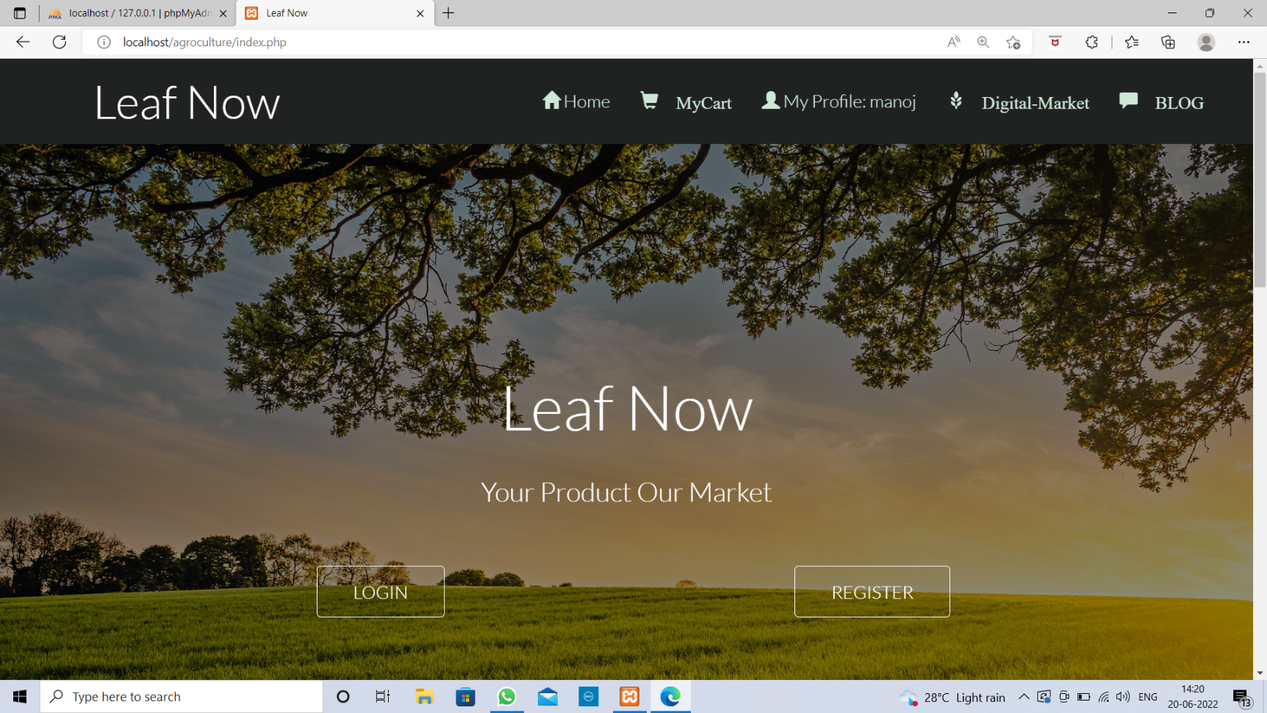

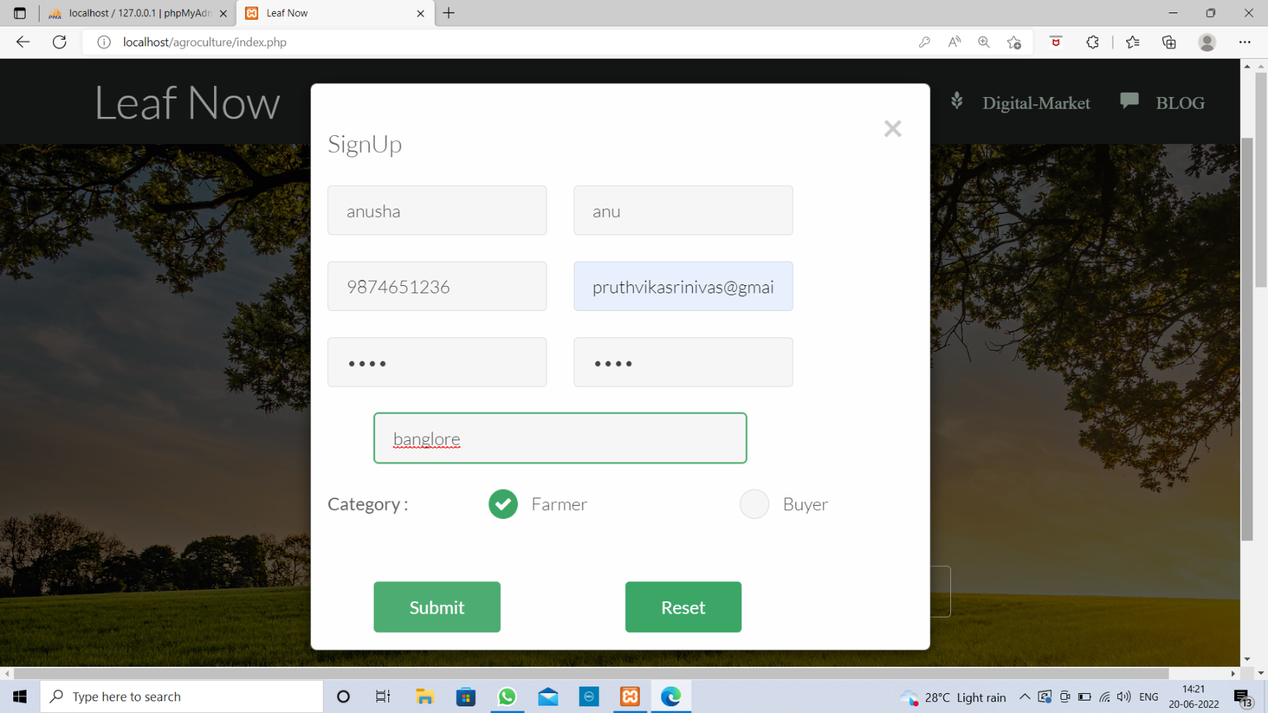

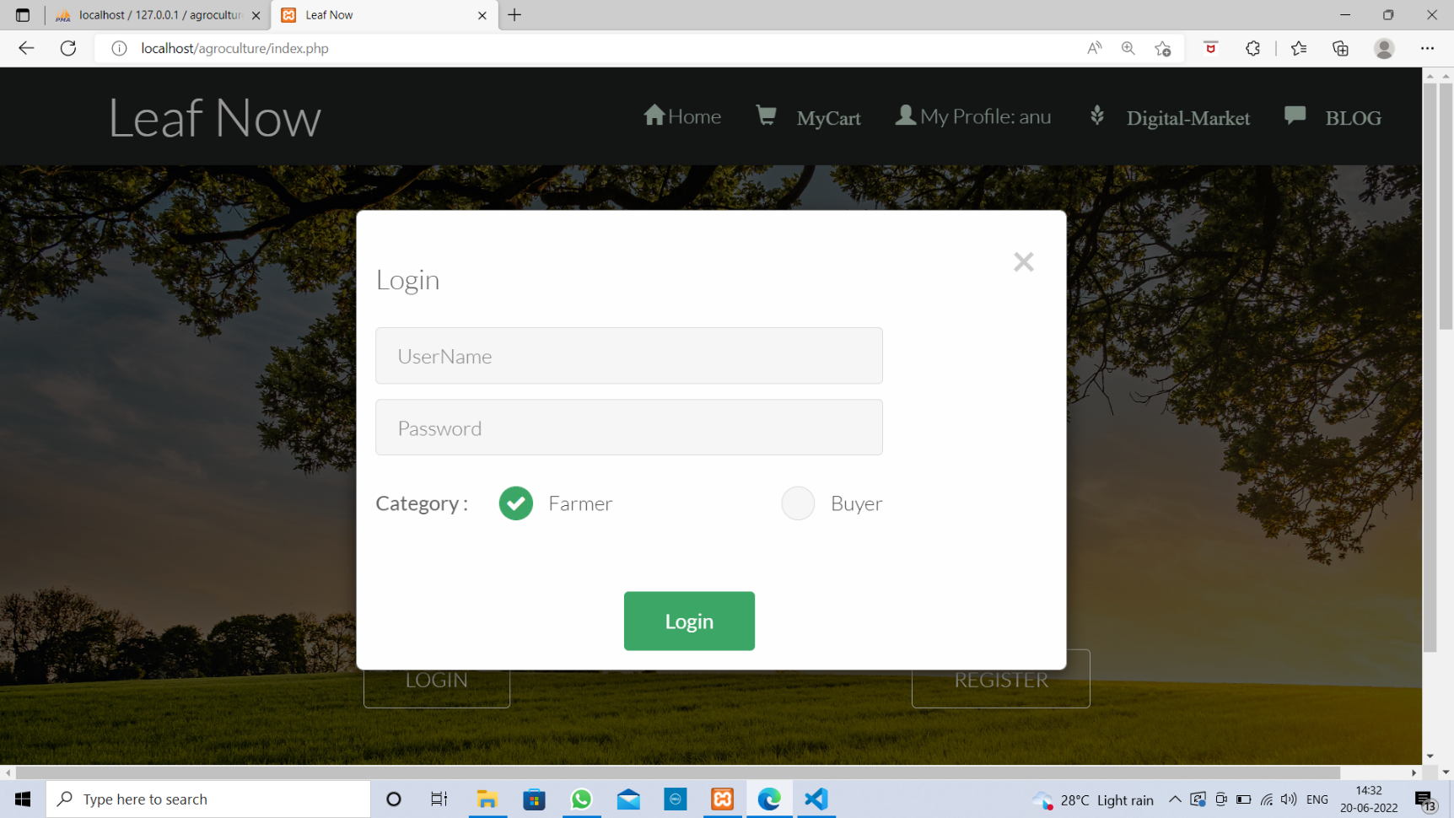

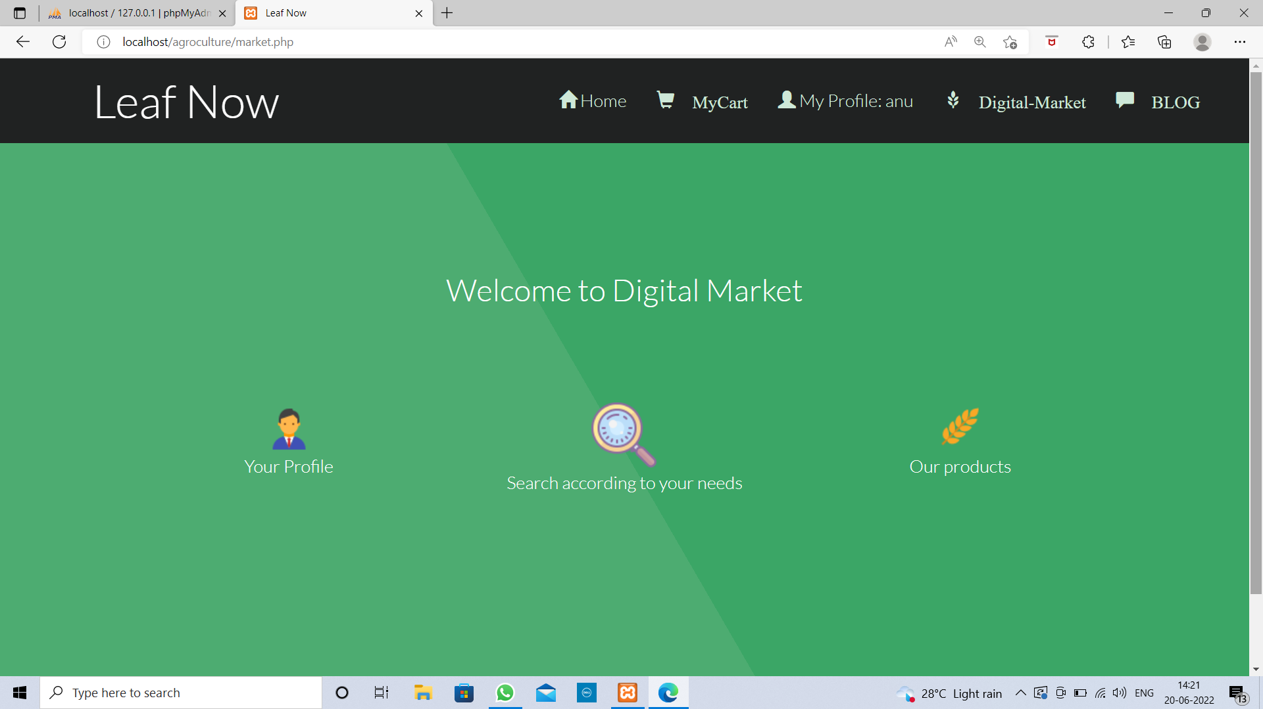

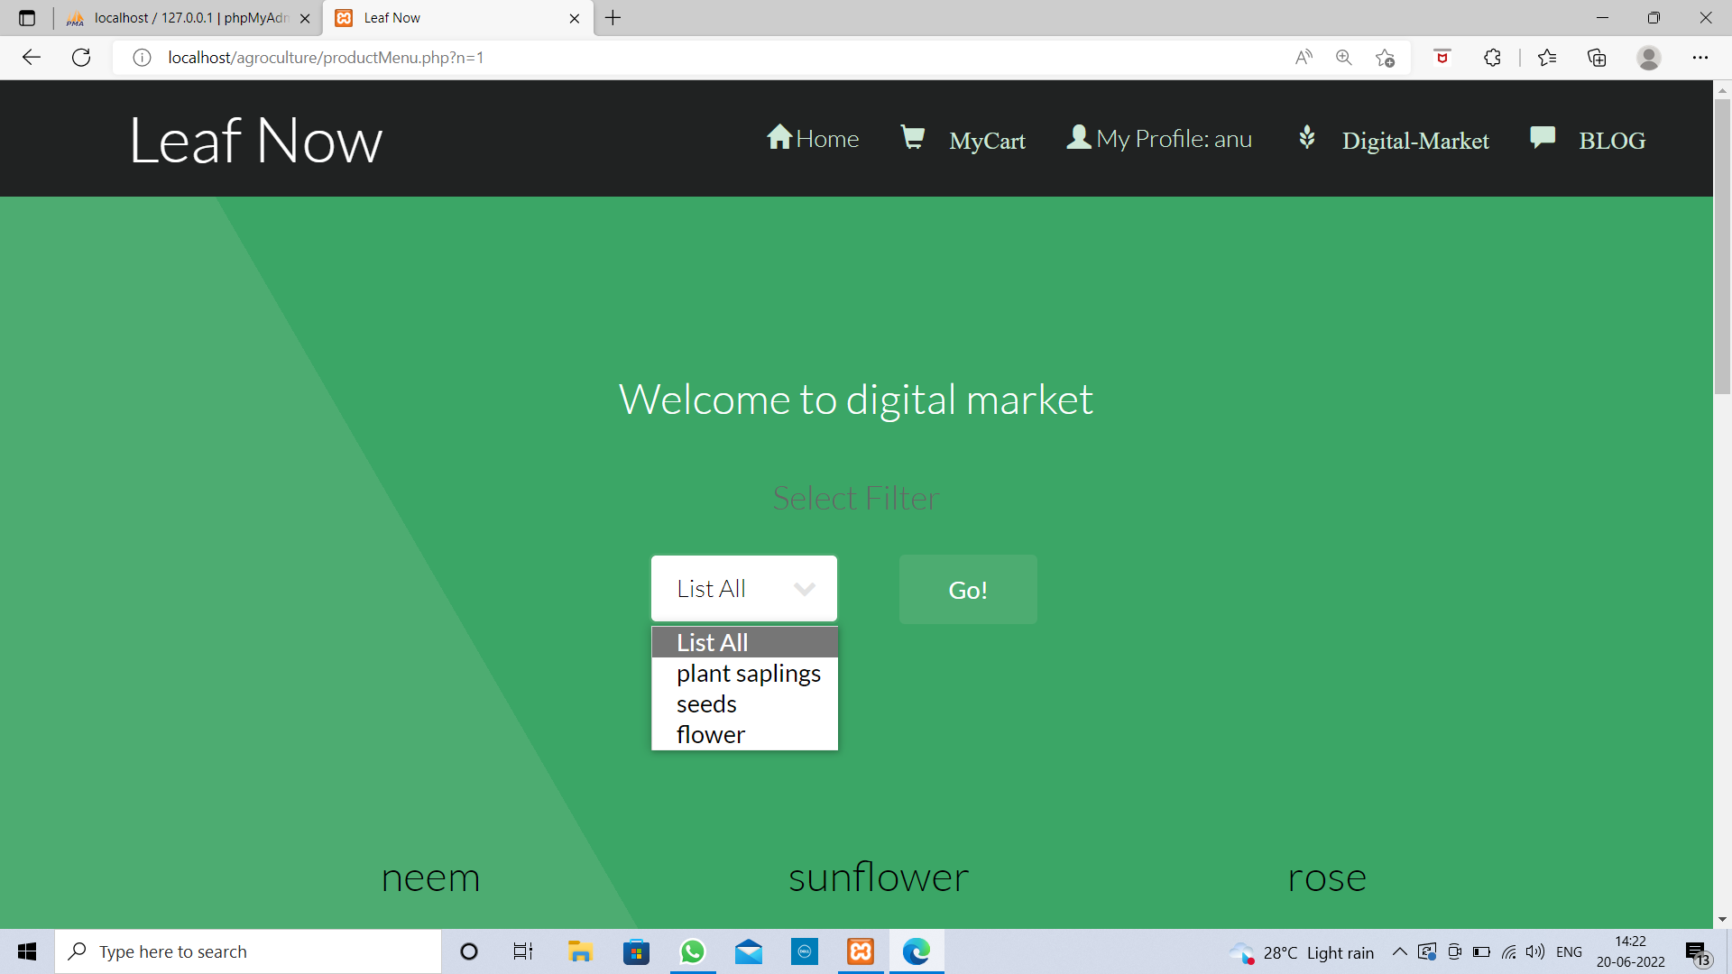

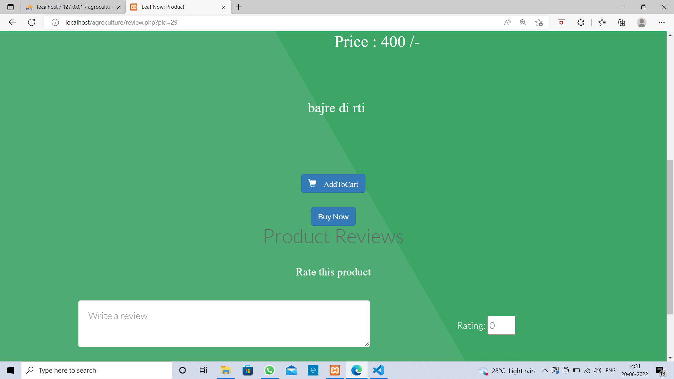

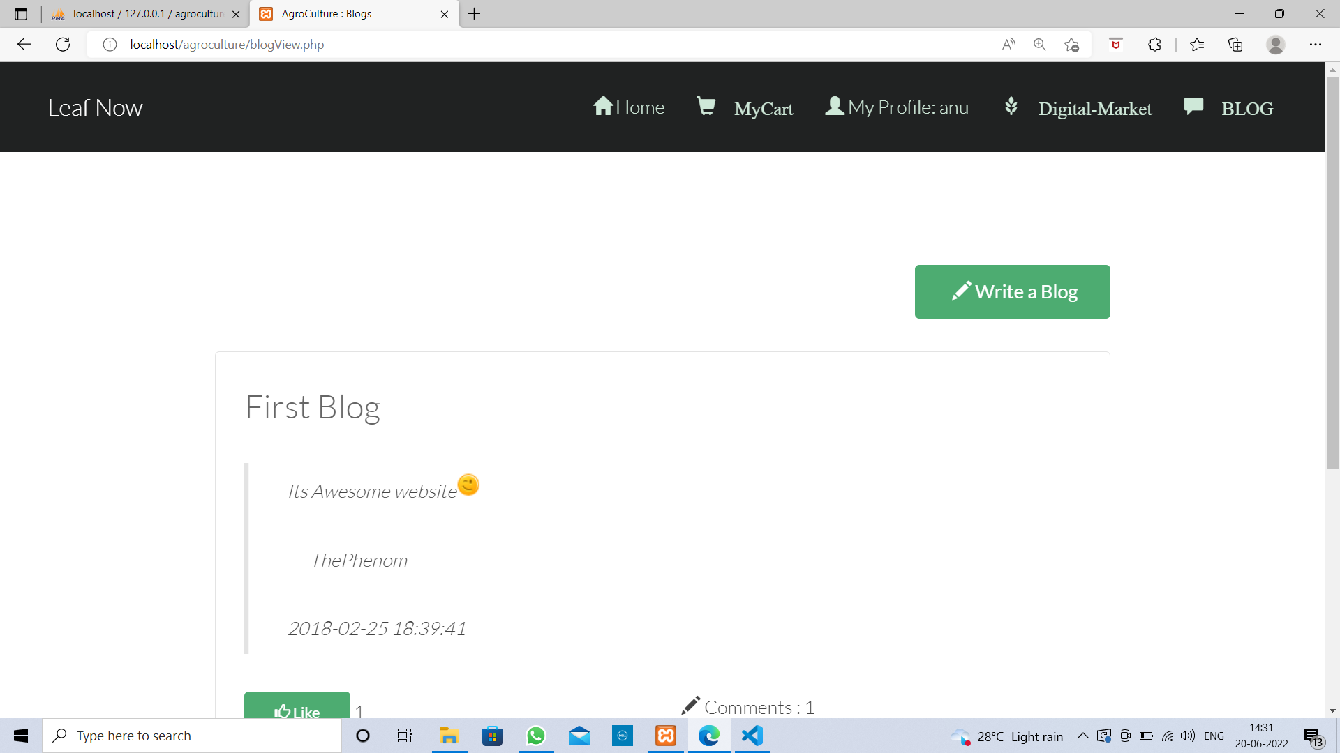

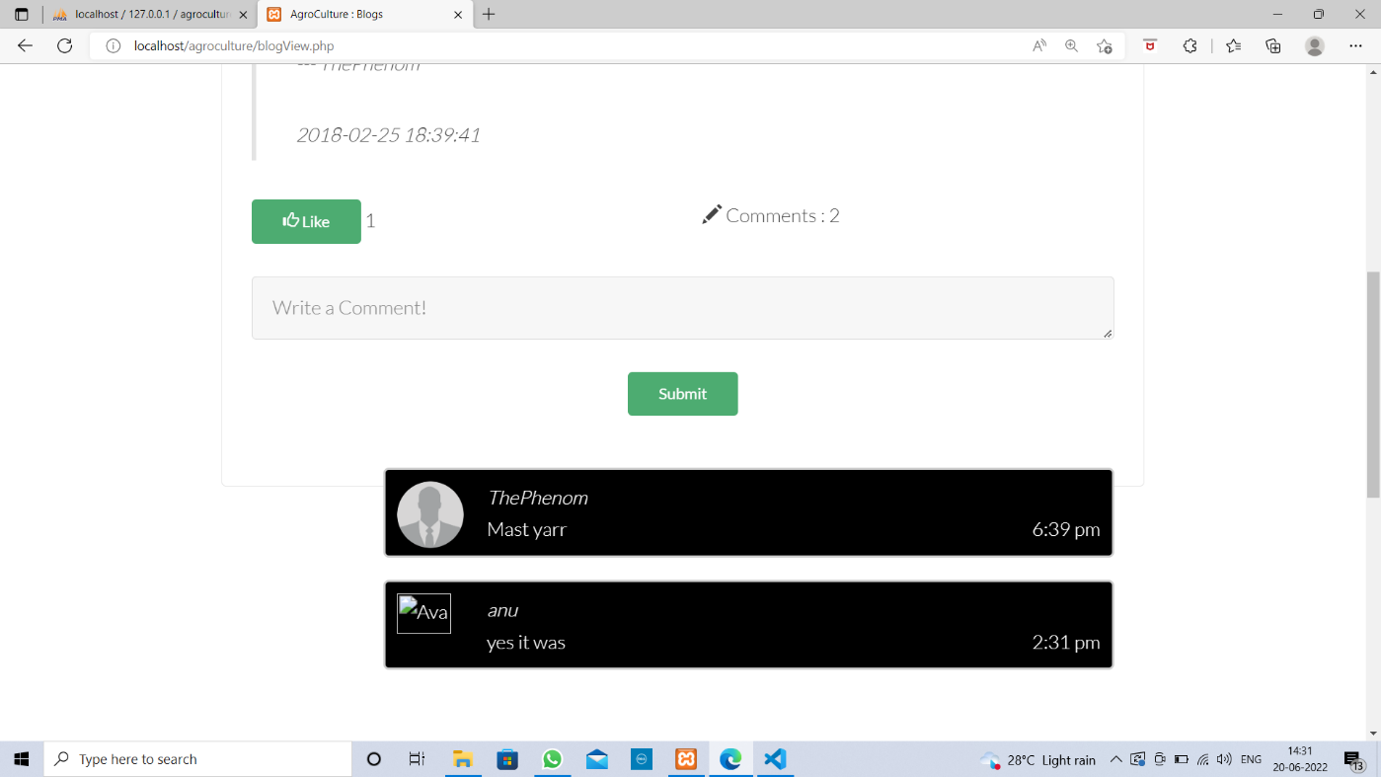

### BIBLIOGRAPHY

* https://[www.w3schools.com](http://www.w3schools.com/)
* https://www.geeksforgeeks org
* https://freefrontend.com
* <https://css-tricks.com/>
* https://www.takeiteasyengineers.com
* https://dev.to/mychi_darko/php-tips-and-tricks-4kpn